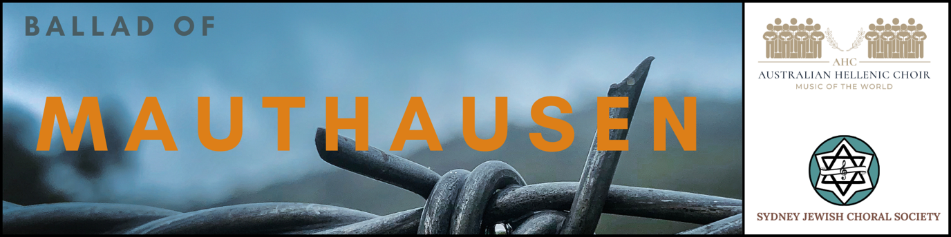

REVIEWS

Australian Jewish News 10 November 2022

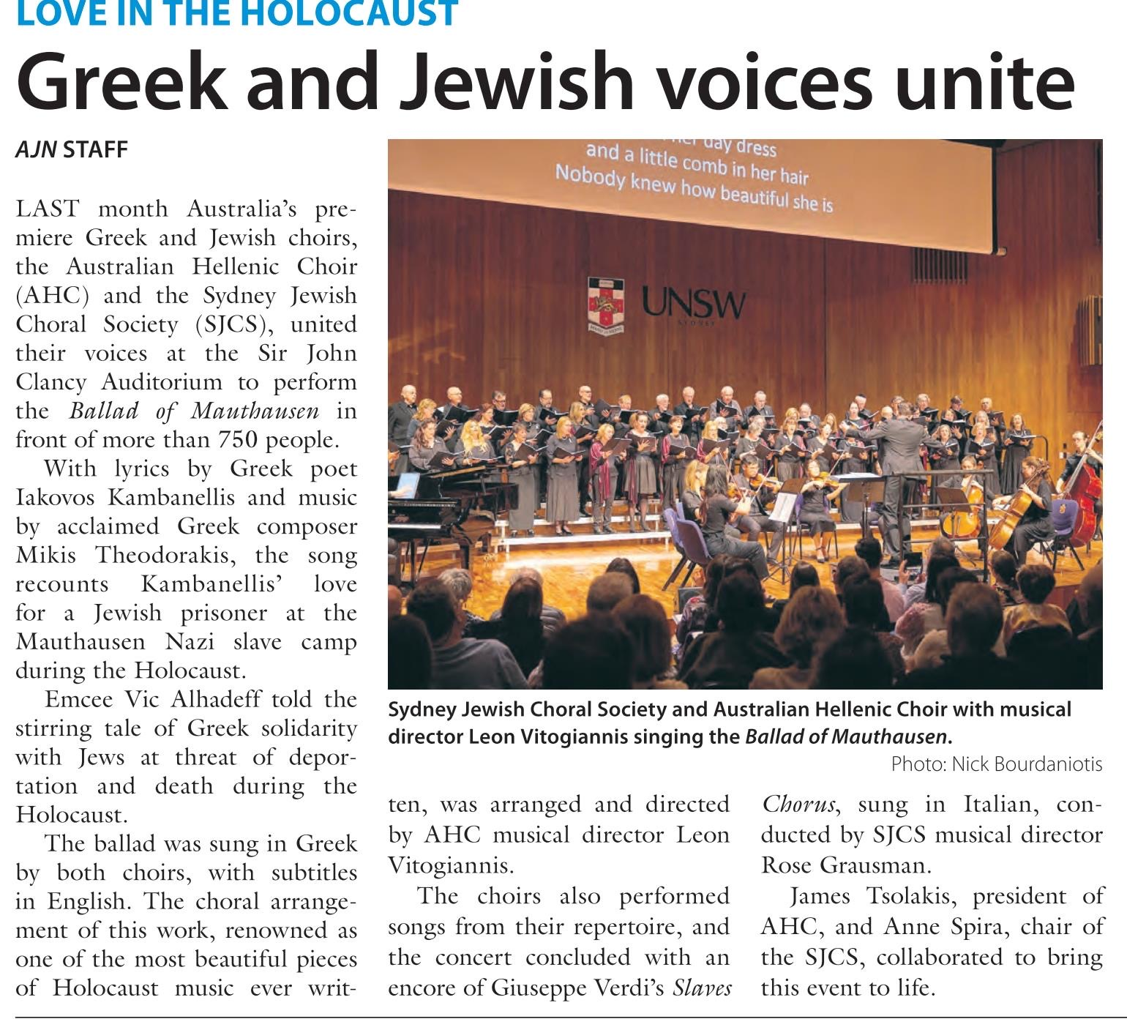

More reviews – see links below:

Plus61Jmedia
https://plus61j.net.au/culture-thought/greek-jewish-choral-performance-soars-above-nazi-darkness/

Syndesmos
https://www.facebook.com/permalink.php?story_fbid=pfbid0wTqWjuaDxyMVYxagdSfK7tKEXNwqESR4EbrcP7gag6CXpGDNTT4Gdd3WDeWfVP4Ql&id=100042746695624

J-wire
https://www.jwire.com.au/united-voices-sing-of-love-in-the-holocaust/

Greek herald
https://greekherald.com.au/community/events/hellenic-and-jewish-choirs-amaze-with-joint-performance-of-the-ballad-of-mauthausen-in-sydney/

